7

WORKING WITH COMPUTERS

**Five Reasons Working With Computers Is Bad For You and How to Stay Healthy**[1]

Working on the computer may sound like the most relaxed job in the world, but it’s quite the contrary. Sitting has long been known to cause back pain and negatively influence circulation, which can promote cardiovascular disease. Extensive use of the keyboard and mouse can lead to stiffening of the muscles in your hands, arms, and neck, as well as inflammation and injuries. Staring at a bright screen for too long can cause dry eyes and headaches. Finally, computer work can be stressful, isolating, and lead to depression and anxiety. In other words, working on the computer is as unhealthy a job as you can imagine.

Let me show you what exactly the culprits are and how you can avoid and fix them.

## **A ________________________________**

Whether you do in front of the computer, the TV, or while reading a book, sitting for long stretches of time is a very serious health risk! Sitting affects your blood circulation, your back experiences a steady stress, you are more likely to drink and eat stuff that isn’t good for you, and you burn very little calories, making it more likely that you overeat. As a result, sitting contributes to a host of conditions, most notably gaining weight, diabetes, heart disease, cancer, and consequently a shortened life span.

**Remedies**

Sitting is perfectly good and normal. It’s just when you do it excessively that it turns into a major health risk. So try to loosen it up and play with alternatives. Here is a list of things you should do:

* Take frequent breaks, at least 5 minutes per hour.
* Walk around and stretch during your breaks.
* Get a standing desk and spend part of your day working while standing upright.
* Exercise before or after work.

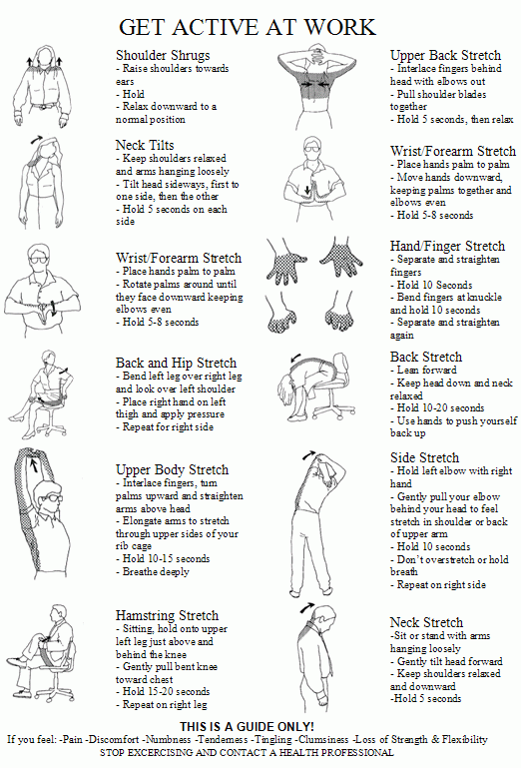

## **B ________________________________**

Bad posture is not necessarily a consequence of sitting. You can develop bad posture from anything you do habitually, whether it’s sitting, standing, or walking. Your daily activities have an impact on your body and shape your muscles; they either tighten or become weak. The typical consequences associated with bad posture while working on the computer are pain in the back, shoulder, and neck, often resulting in tension headaches.

**Remedies**

* Do everything recommended above to combat sitting-related health risks, especially taking frequent breaks and stretching.
* [*Self-massage*](https://www.painscience.com/articles/self-massage.php) your back and neck.
* Set up your monitor ergonomically; the top edge should be at eye level, the display should be at arm’s length from your face and angled slightly backward.
* Get an [*ergonomic office chair*](https://www.makeuseof.com/tag/how-to-buy-a-sweet-office-chair-for-less/) or maybe an exercise ball to support and strengthen your lower back.
* [*Work on a healthy sitting posture*](https://www.makeuseof.com/tag/apps-improve-posture-fix-back-neck-pain/); apparently [*leaning back is actually best for your back*](http://news.bbc.co.uk/2/hi/6187080.stm).

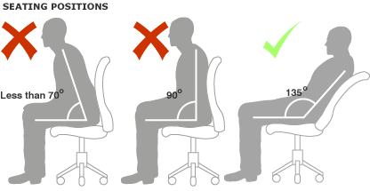

## **C ________________________________**

Repetitive Strain Injury (RSI) is caused by continual physical movements that damage tendons, nerves, muscles, and other soft body tissues. This is actually a severe form of bad posture that most frequently affects the hands and leads to Carpal Tunnel Syndrome.

**Remedies**

* As above, take frequent breaks and stretch.
* Adjust your posture to reduce strain on your wrists.
* Consciously keep your hands and arms relaxed.
* Use very little force when you use the mouse or keyboard.
* Make sure your hands are warm.

## **D ________________________________**

Staring at a bright screen for hours can lead to eye fatigue or eye strain, headaches, blurred vision, burning, itching or tearing eyes, and temporary vision disorders. Fortunately, eye strain rarely results in a permanent condition and symptoms can be prevented or cured rather easily.

**Remedies**

* Use a quality display of sufficient size.
* Avoid glare.
* Keep at least one arm length between your eyes and your display.
* Keep blinking.
* Follow the 20/20/20 rule, i.e. every 20 minutes, focus on an object 20 feet (6 meters) away for 20 seconds. You can use tools like [EVO](http://www.protectyourvision.org/) or [EyeLeo](http://eyeleo.com/) to remind you.
* Improve the lighting in the room, particularly install bias lighting.
* Use [f.lux](http://stereopsis.com/flux/) to [automatically dim your display](https://www.makeuseof.com/tag/prevent-late-night-computer-activities-from-disrupting-your-circadian-rhythm-with-f-lux/) as your room gets darker.

## **E ________________________________**

Computers are very efficient tools in that they help us with getting more work done in less time. At the same time, you spend less face-to-face time with your colleagues, family, or friends. This can lead to isolation, anxiety, and [depression](https://www.makeuseof.com/tag/7-online-resources-depressed-suicidal/), i.e. both physical and mental health issues. The symptoms are manifold and can include tense muscles, back pain, headaches, poor sleep (insomnia), increased or flat breathing, quickened pulse, and generally signs of stress, depression, or anxiety.

**Remedies**

* Breathe consciously.
* In addition to stretching, go for a brisk walk or run up and down the stairs to work off stress levels.
* During your frequent breaks, seek out social interactions.
* Have meals with colleagues or friends.
* Don’t forget to drink lots of water.
* Plan for social activities after work.
* Meditate before or after work.
* Exercise before or after work.

## **CONCLUSION**

Are computers bad for health? Too much of anything is bad for you. Working with a computer for hours on end day in day out is very straining for your body and can cause very serious health issues. Fortunately, you can avoid pain and misery with only a few simple routines. The key changes are to take frequent short breaks, get up to walk and stretch at least once an hour, actively relax, interact with other people, and especially if you have a lot of stress, remember that you must exercise to stay healthy.

1. Adapted from: Seiber. Tina. 5 reasons working with computers is bad for you and how to stay healthy. In: *Make Use of.com.* [online]. [cit. 19.09.2018]. Dostupné z: https://www.makeuseof.com/tag/5-reasons-working-with-computers-is-bad-for-you-how-to-stay-healthy/