Lesson 2

**What is inclusion?**

<https://www.youtube.com/watch?v=3VMz06iVzqs&t=2s>

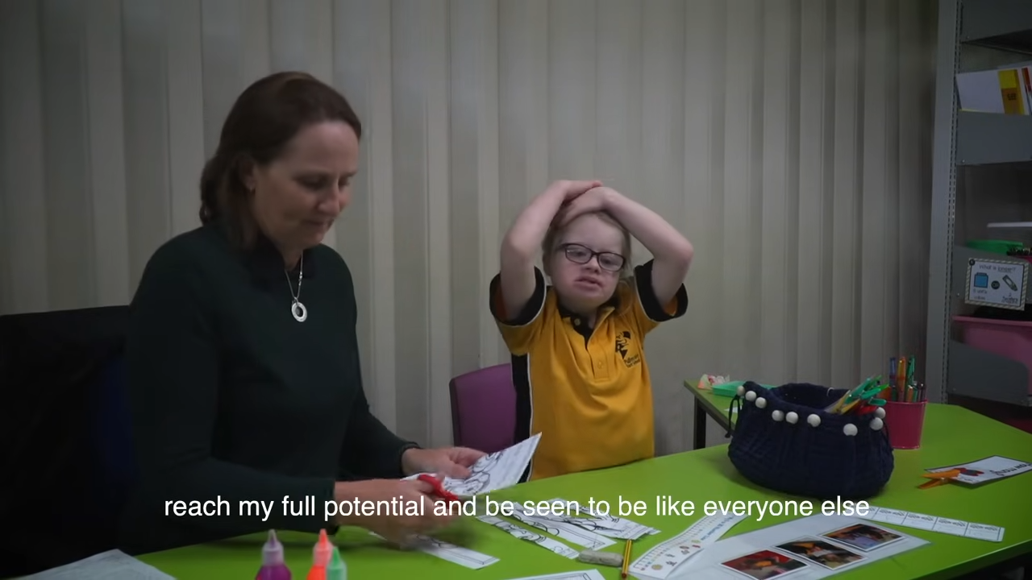

* Create a list of terms – vocabulary list - related to special education from the video.
* Reflect on the educational setting you saw in the video and prepare 5 sentences as feedback – what have you seen and heard?
* Describe Down syndrome as you observe it in the pupil - girl—what specific characteristics of this disability are visible and apparent and what specific characteristics are not visible but you can predict them…?