SPECIAL EDUCATION

Odkaz:

<https://www.youtube.com/watch?v=IcHzjV9xAFg>

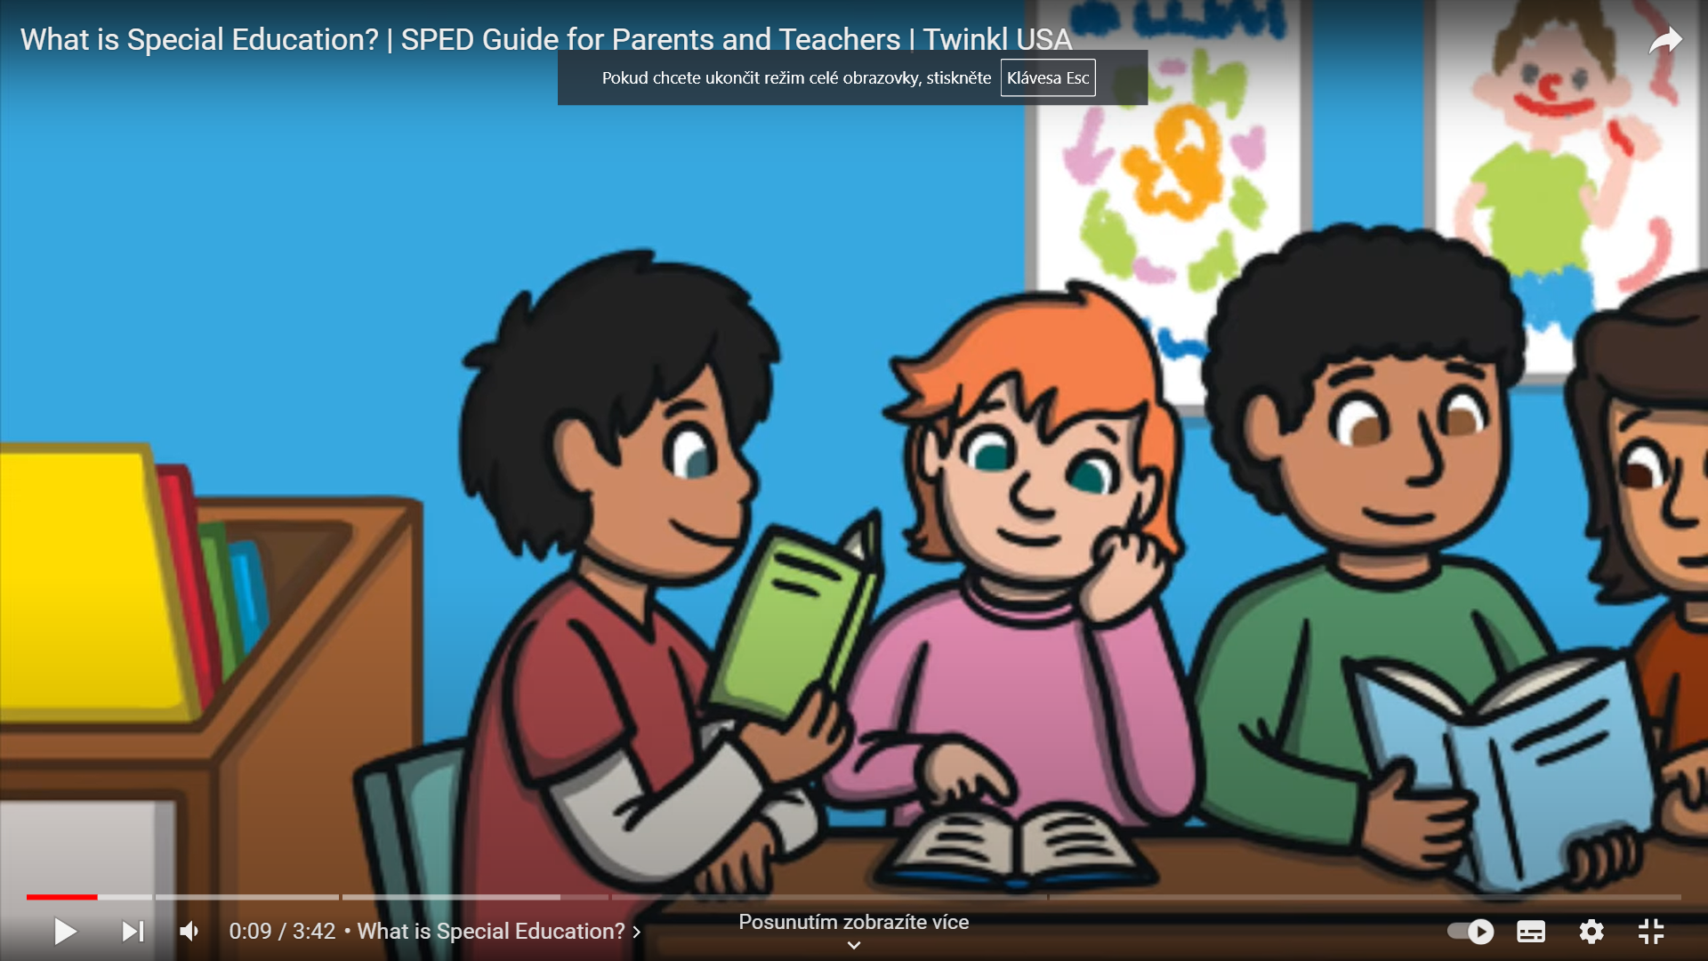

* Watch the video and provide a summary of 5 to 10 sentences detailing its content.
* Identify and compile specialized terms related to special education, creating a glossary relevant to the content of this video.