**A SOAR analysis of your minority group project**

**What is a SOAR Analysis?**

**"**SOARis a strategic planning framework with an approach that focuses on strengths and seeks to understand the whole system by including the voices of the relevant stakeholders.  SOAR conversations center on what an organization is doing right, what skills dould be enhanced, and what is compelling to those who have a 'stake' in the organization's success." (Stavros, J. & Hinrichs, G. (2009).  *The thin book of SOAR:  Building strengths-based strategy.)*

SOAR is a "...positive approach to strategic thinking and planning that allows an organization to construct its future through collaboration, shared understanding, and a commitment to action." (Stavros, J. & Hinrichs, G. (2009).  *The thin book of SOAR:  Building strengths-based strategy.)*

* **Strengths** What can we build on?
* **Opportunities** What are our stakeholders asking for?
* **Aspirations** What do we care deeply about?
* **Results** How do we know we are succeeding?

By using a SOAR analysis, an organization focuses on what they are doing well, what can be improved and what is most important to stakeholders.  Using the SOAR approach, strategic plans can be more dynamic, creative and optimistic.

SOAR uses Appreciative Inquiry, an approach to organizational analysis and learning. Intended for discovering, understanding and fostering innovations in social organizational arrangements and processes.

See:  
Stavros, J. & Cole, M. (2013). SOARing towards positive transformation and change. *Development Policy Review*, 1(1), 10-34. Retrieved from: <https://www.researchgate.net/publication/259975881_SOARing_towards_positive_transformation_and_change>

Stavros, J., Cole, M. & Hitchcock, J. (2014, Aug.).  Appreciative inquiry research review & notes: A research review of SOAR.  *AI Practitioner,* 16(3).  Retrieved from: <https://www.researchgate.net/publication/284380692_Appreciative_Inquiry_Research_Review_Notes_A_Research_Review_of_SOAR>

**SOAR Analysis**

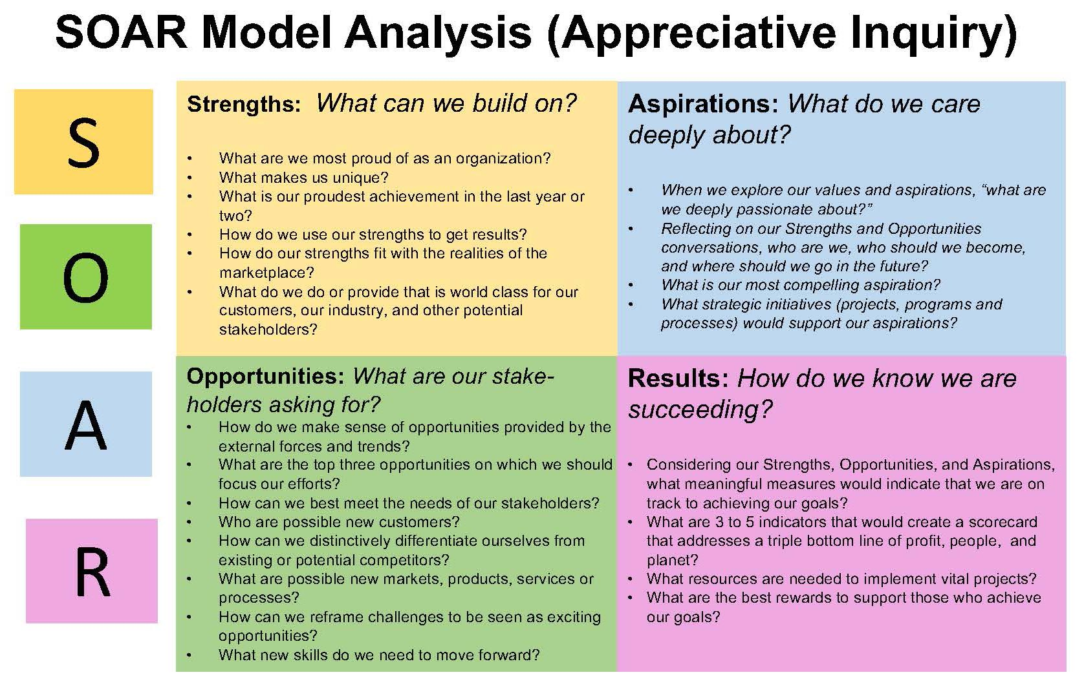

Source: Stavros, J. & Hinrichs, G. (2009). The thin book of SOAR: Building strengths-based strategy. Bend, OR : Thinbook Publishing.