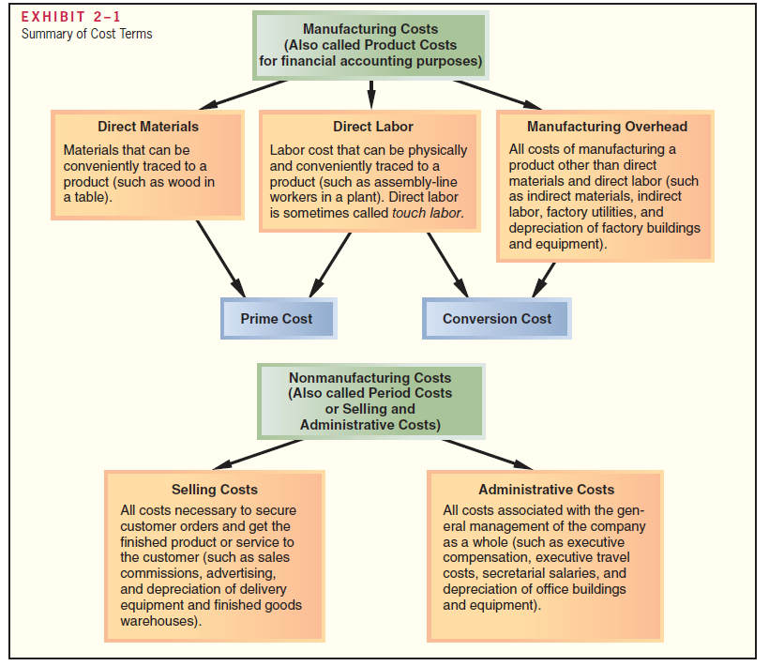

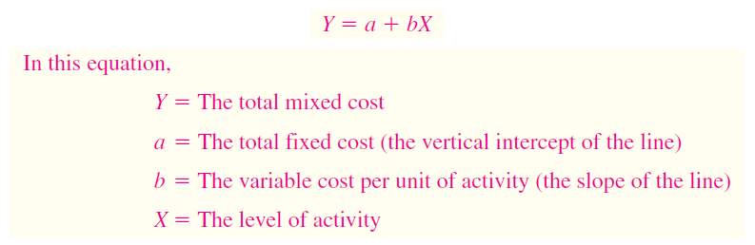

**Exercise 1**

The company incurs a mixed cost called fees paid to the state. It includes a license fee of $25,000 per year plus $3 per rafting party paid to the state’s Department of Natural Resources.

* Write an equation for the total mixed cost in general form

Y= a + bX

* Fill the mixed total cost equation in the general shape of the data that you know

Y = $25 000 + $3.00X

The company expects to organize 800 rafting parties in the next year.

Y = a+bX

Y = $25 000 + $3*800

Y = $ 27 400

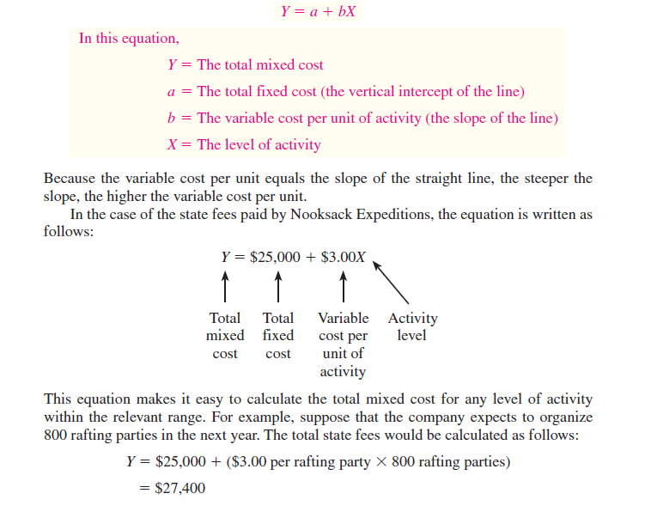

**Exercise 2**

The company incurs a mixed cost called fees paid to the state. It includes a license fee of $25,000 per year plus $3 per rafting party paid to the state’s Department of Natural Resources. Suppose that the company expects to organize 800 rafting parties in the next year.

* Write an equation for the total mixed cost in general form
* Fill the mixed total cost equation in the general shape of the data that you know
* Calculate the total mixed cost



**Exercise 3**

**OPERATIONS DRIVE COSTS**

White Grizzly Adventures is a snowcat skiing and snowboarding company in Meadow Creek, British Columbia, that is owned and operated by Brad and Carole Karafil. The company shuttles 12 guests to the top of the company’s steep and tree-covered terrain in a modified snowcat. Guests stay as a group at the company’s lodge for a fixed number of days and are provided healthy gourmet meals. Brad and Carole must decide each year when snowcat operations will begin in December and when they will end in early spring, and how many nonoperating days to schedule between groups of guests for maintenance and rest. These decisions affect a variety of costs. Examples of costs that are fixed and variable with respect to the number of days of operation at White Grizzly include:

**Solution:**

|  |  |
| --- | --- |
| **Cost** | **Cost Behavior—Fixed or Variable with Respect to Cost Days of Operation** |
| Property taxes | Fixed |
| Summer road maintenance and tree clearing | Fixed |
| Lodge depreciation | Fixed |
| Snowcat operator and guides | Variable |
| Cooks and lodge help | Variable |
| Snowcat depreciation | Variable |
| Snowcat fuel | Variable |
| Food | Variable |
| The costs of food served to guests theoretically depend on the number of guests in residence. However, the lodge is almost always filled to its capacity of 12 persons when the snowcat operation is running, so food costs can be considered to be driven by the days of operation. | |

**The High-Low Method**

The high-low method is based on the rise-over-run formula for the slope of a straight line. As previously discussed, if the relation between cost and activity can be represented by a straight line, then the slope of the straight line is equal to the variable cost per unit of activity. Consequently, the following formula can be used to estimate the variable cost:

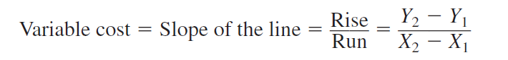

To analyze mixed costs with the high-low method begin by identifying the period with the lowest level of activity and the period with the highest level of activity. The period with the lowest activity is selected as the first point in the above formula and the period with the highest activity is selected as the second point. Consequently, the formula becomes:

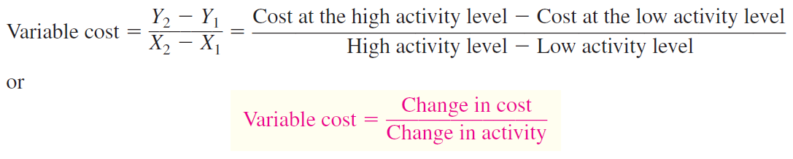

Therefore, when the high-low method is used, the variable cost is estimated by dividing the difference in cost between the high and low levels of activity by the change in activity between those two points.

**Exercise 4**

Assume that Brentline Hospital is interested in predicting future monthly maintenance costs for budgeting purposes. The senior management team believes that maintenance cost is a mixed cost and that the variable portion of this cost is driven by the number of patient-days. Each day a patient is in the hospital counts as one patient-day. The hospital’s chief financial officer gathered the following data for the most recent seven-month period:

|  |  |  |
| --- | --- | --- |
| **Month** | **Activity Level: Patient-Days** | **Maintenance Cost Incurred** |
| January | 5,600 | $ 7,900 |
| February | 7,100 | $ 8,500 |
| March | 5,000 | $ 7,400 |
| April | 6,500 | $ 8,200 |
| May | 7,300 | $ 9,100 |
| June | 8,000 | $ 9,800 |
| July | 6,200 | $ 7,800 |

* Determine the high activity level

8 000 patient-days – June; $ 9,800

* Determine the low activity level

5 000 patient days – March; $ 7,400

* Determine the change between high activity level and low activity level

8 000 – 5 000 = change is 3 000 patient-days

$ 9,800 - $ 7,400 = - $ 2 400 change in cost

* Determine variable cost per unit (patient-day)

Variable cost = change in cost / change in activity level = $2400 / 3 000 = $0.80 per patient-day

* Determine total variable cost

Total variable cost = $0.80*8 000 = $6 400

* Determine fixed cost

Fixed cost = total cost – variable cost = $ 9 800 – ($0.80* 8 000) = = $ 9 800 - $6 400 = $ 3 400

* Determine equation for total cost (mixed cost)

Y = a+bX

Y= $ 3 400 + $0.80X

Y= $ 3 400 + $0.80*8000

Solution:

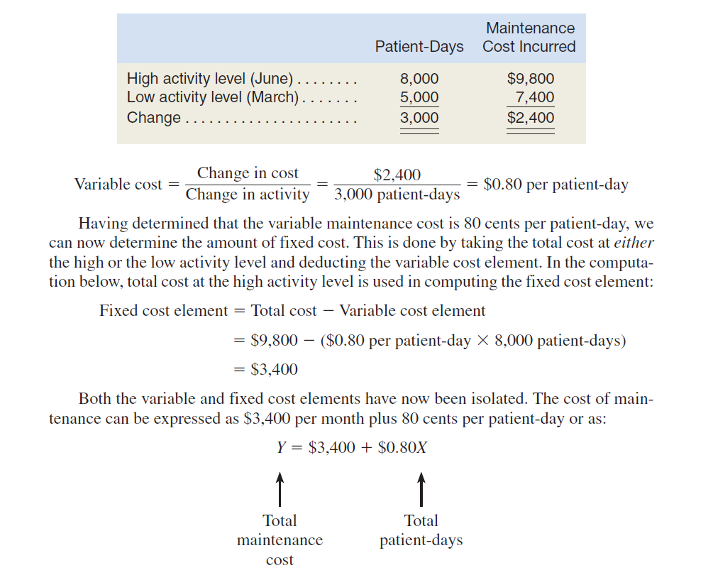

**Exercise 5**

Porter Company manufactures furniture, including tables. Selected costs are given below:

1. The tables are made of wood that costs $100 per table.

2. The tables are assembled by workers, at a wage cost of $40 per table.

3. Workers assembling the tables are supervised by a factory supervisor who is paid $38,000

per year.

4. Electrical costs are $2 per machine-hour. Four machine-hours are required to produce a table.

5. The depreciation on the machines used to make the tables totals $10,000 per year. The

machines have no resale value and do not wear out through use.

6. The salary of the president of the company is $100,000 per year.

7. The company spends $250,000 per year to advertise its products.

8. Salespersons are paid a commission of $30 for each table sold.

9. Instead of producing the tables, the company could rent its factory space for $50,000 per year.

* Classify these costs according to the various cost terms

**Solution:**

|  |  |
| --- | --- |
| Point | Type of cost |
| 1 | Variable cost, ~~fixed cost, period cost (selling and administrative cost),~~ product cost (direct materials, ~~direct labor, manufacturing overhead), sunk cost, opportunity cost~~ |
| 2 | Variable cost, fixed cost, period cost (selling and administrative cost), product cost (direct materials, direct labor, manufacturing overhead), sunk cost, opportunity cost |
| 3 | Fixed cost, manufacturing overhead |
| 4 | Variable cost, manufacturing overhead |
| 5 | Fixed cost, sunk cost |
| 6 | Fixed cost, period cost (administrative cost) |
| 7 | Fixed cost, period cost (selling cost) |
| 8 | Variable cost, period cost (selling cost) |
| 9 | Opportunity cost |

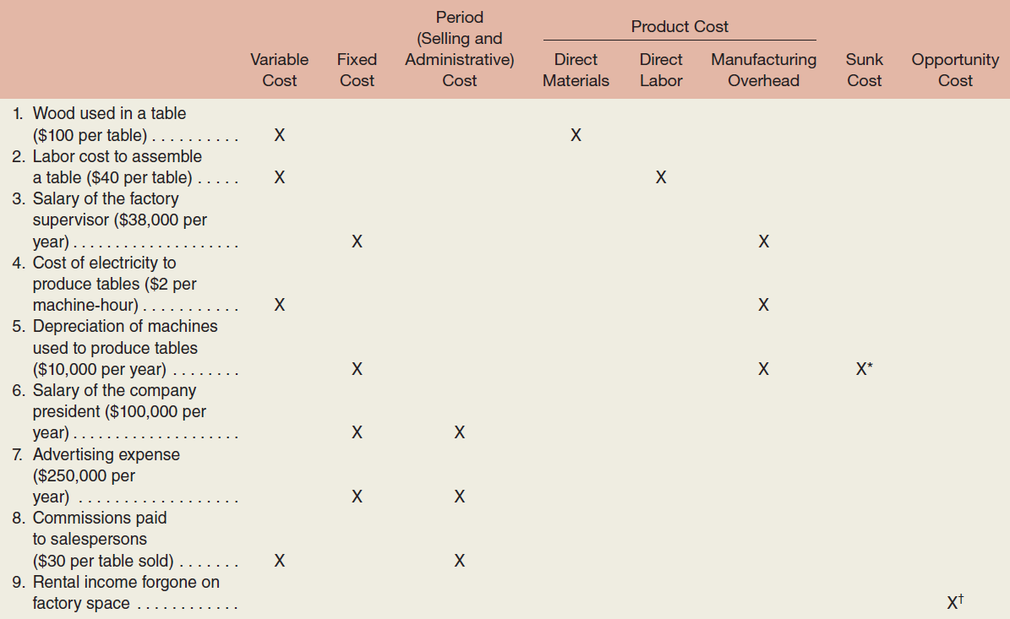

*This is a sunk cost because the outlay for the equipment was made in a previous period.

†This is an opportunity cost because it represents the potential benefit that is lost or sacrificed as a result of using the factory space to produce tables. Opportunity cost is a special category of cost that is not ordinarily recorded in an organization’s accounting records. To avoid possible confusion with other costs, we will not attempt to classify this cost in any other way except as an opportunity cost.

**Exercise 6**

The administrator of Azalea Hills Hospital would like a cost formula linking the administrative costs involved in admitting patients to the number of patients admitted during a month. The Admitting Department’s costs and the number of patients admitted during the immediately preceding eight months are given in the following table:

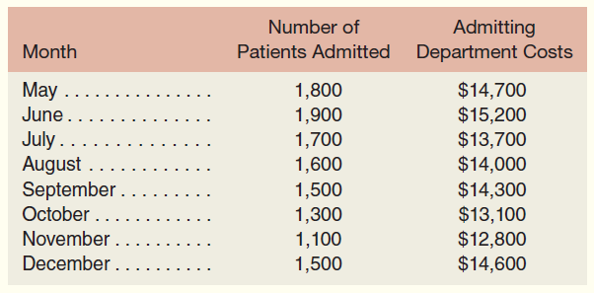

* (1) Use the high-low method to estimate the fixed and variable components of admitting costs.

1 900 – 1 100 = change is 800 activity level

$15 200 – $12 800 = change in cost is $2 400

Variable cost per unit = change in cost / change in activity level = $2 400/ 800 = $3 per unit

Total variable cost = = $3* 1 900 = $5 700

Fixed cost = total cost – variable cost = $15 200 - $5 700 = $9 500

* (2) Express the fixed and variable components of admitting costs as a cost formula in the form

Y = a + bX.

Y = $9 500 +$3X

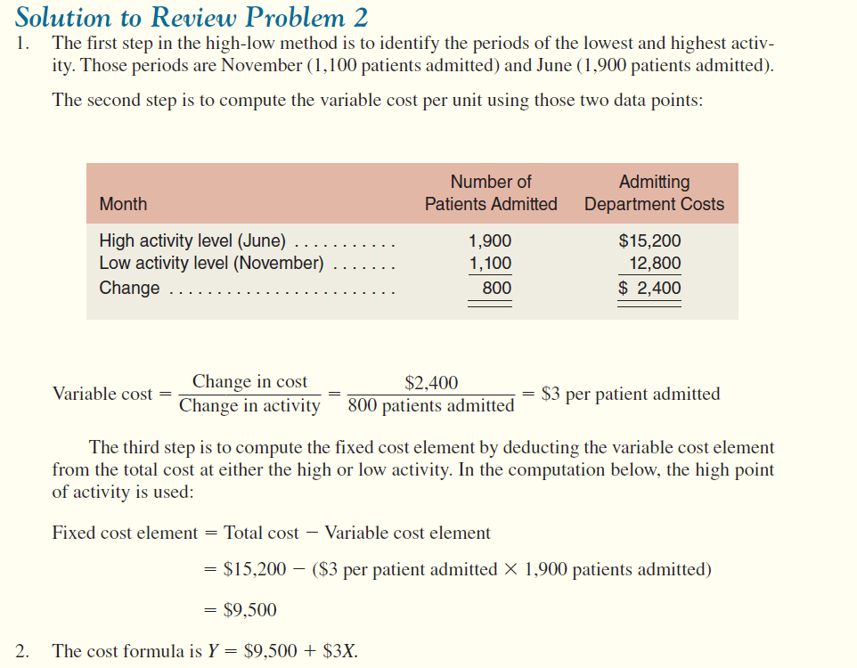

**Exercise 7**

Calculate the break-even point, assuming that the company has a fixed cost of CZK 1,500,000, the unit selling price is CZK 50 and the unit variable cost is CZK 20.

BEP = Fixed cost / (price per unit – variable cost per unit)

BEP = 1 500 000 / (50 – 20)

BEP = 50 000 pcs (units, tables, computers, mineral waters….)

Sales = price per unit * quantity = P*Q = 50 * 50 000 =250 000 CZK

Costs = 250 000 CZK

Profit or loss = sales – costs = 250 000 – 250 000 = 0

Or

Sales = cost

P*Q = variable cost per unit*Q + fixed cost

**Exercise 8**

Voltar Company manufactures and sells a specialized cordless telephone for high electromagnetic radiation environments. Company manufactures and sell 20 000 units. Fixed costs are $240 000.

|  |  |  |  |
| --- | --- | --- | --- |
| **Items** | **Total ($)** | **Per unit ($)** | **Percent of Sales (%)** |
| Sales |  | 60 | 100 % |
| Variable expenses |  | 45 |  |
| Contribution margin |  |  |  |
| Fixed expenses |  |  |  |
| Net operating income |  |  |  |

* Fill in the table
* Compute the company’s break-even point in both units and sales dollars.
* Assume that next year management wants the company to earn a profit of at least $90,000. How many units will have to be sold to meet this target profit?
* Compute the company’s margin of safety in both dollar and percentage.