**How to comment your Lean CANVAS model, part one**

Define your main idea of business according CANVAS

**Products and Services**

Describe in depth your products or services (technical specifications, drawings, photos, sales brochures, and other items belong in Appendices). What factors will give you competitive advantages or disadvantages? Examples include level of quality or unique or proprietary features.

Your short description. ...........................................................................................................................................................................................................................................................................................................................................................................................................................................................................................................................................................................................................................

**Market analysis (Environment, Competition, Customer, Company analysis). We need to go through those analyses**:

1. ***The situation in external environment – PEST analysis***

The criteria are Political and Legal (P), Economic (E), Social (S), Technical (T), the analysis expands its external aspects (Opportunities and Threats) and to get greater understanding of the external environment and the marketplace. Give the mark of importance (5- the most, 1- least important)

|  |  |  |  |
| --- | --- | --- | --- |
| Political and Legal (P) | Importance (points) | Economic (E) | Importance (points) |
|  |  |  |  |
| Total points |  | Total points |  |
| Social (S) | Importance (points) | Technical (T) | Importance (points) |
|  |  |  |  |
| Total points |  | Total points |  |

1. **Competition Analysis**

What products and companies will compete with you? List your major competitors (table below). Now analyze each major competitor. In a few words, state how you think they compare. In the final column, estimate the importance of each competitive factor to the customer. 5 = critical; 1 = not very important

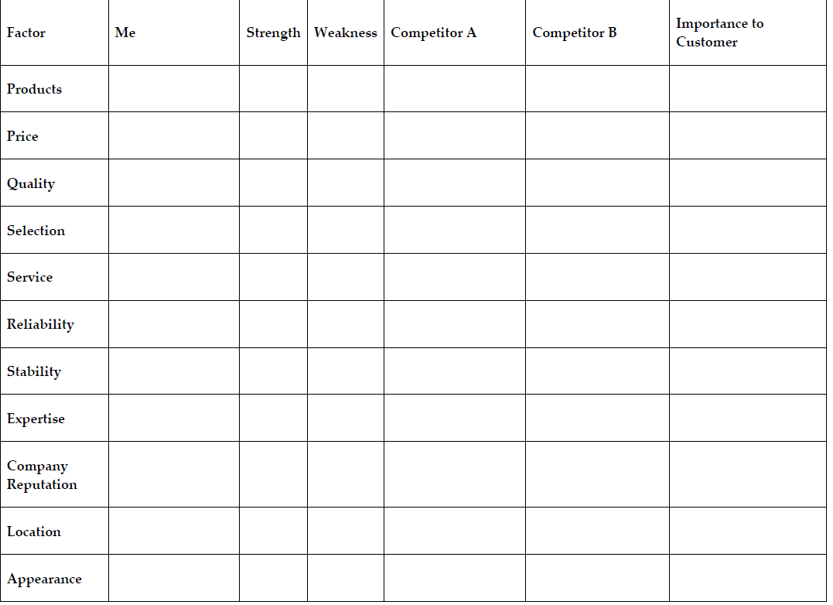

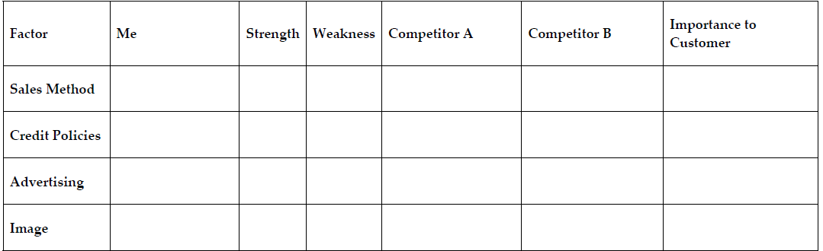

1. **SWOT analysis**

SWOT is a strategic planning tool used to evaluate and manage internal and external factors that affect your organisation. It stands for Strengths (S), Weaknesses (W), Opportunities (O) and Threats (T). You are putting together two points of view – internal (S,W) and external (O,T). Give the mark of importance (5- the most, 1- least important)

|  |  |  |  |  |
| --- | --- | --- | --- | --- |
| Internal | Strengths (S) | Importance (points) | Weaknesses (W) | Importance (points) |
|  |  |  |  |
| Total points |  | Total points |  |
| External | Opportunities (O) | Importance (points) | Threats (T) | Importance (points) |
|  |  |  |  |
| Total points |  | Total points |  |

Which part of SWOT is the best?..................................................

Which part of SWOT has minimum points........................................

1. **Customer definition**

***Identify your targeted customers, their characteristics, and their geographic locations, otherwise known as their demographics (age,gender)....***

................................................................................................................................................................................................................................................................................................................................................................................................................................

And after that you will comment each “box” in lean canvas model.