**MICROECONOMICS X.**

1. The TR curve is described by the following function: 20Q + Q². Average income for 10 units are:
2. 20
3. 30
4. 40
5. 50
6. cannot be determined
7. The company's demand curve is characterized as follows:

|  |  |  |  |  |  |
| --- | --- | --- | --- | --- | --- |
| **P (CZK)** | 5 | 4 | 3 | 2 | 1 |
| **Q (quantum in pcs)** | 8 | 12 | 17 | 22 | 27 |

MC and AC are constant at level CZK 4.50. The company produces only the given volume of production. How much profit will there be if the company wants to maximize it?

1. The figure below shows the cost functions and the individual demand curve of one perfectly competitive company. Answer the following questions:

AC

AVC

CZK/q

70

50

45

38

30

20

8 13 18 20 Q

MC

a) What will be the equilibrium quantity of production?

b) What will be the size of TR from this production?

c) What will be the TC for the production of this production?

d) What profit does the company make? Determine its size.

e) What will be the price and output of the "long-term period"?

f) What volume of production will the company produce at the price of CZK 25? Distinguish between short and long periods and explain.

g) Determine the size of fixed costs.

1. A perfectly competitive company sells a product for CZK 1,000. Determine the optimal volume of production, if you know:

|  |  |  |  |  |  |
| --- | --- | --- | --- | --- | --- |
| Q | 1 | 2 | 3 | 4 | 5 |
| TC | 1000 | 1500 | 2300 | 3300 | 5000 |

What happens when the market price of a product drops to CZK 800?

1. Decide whether the statements below are valid or not:

a) A perfectly competitive company always strives for production at a point corresponding to the minimum of the AC curve.

b) When the VCs are consistently higher than the TRs, the firm should close its production.

c) The complete equilibrium condition of a perfectly competitive firm can be written in the form P = AR = MR = MC.

d) The assumption of perfect information of all subjects is a necessary condition of the model of perfect competition.

1. The condition of the company's equilibrium in a perfectly competitive market can be most accurately expressed by the relationship:

a) MC = MR = AC = AR = P

b) MC = AC = AR = P

c) MC = MR = AFC = AR

d) MC = AVC = TR = P

e) none of the above applies.

1. Assume that a perfectly competitive industry has four companies with the following supply functions. What is the market supply of this industry?

Q1 = 8 + 2P, Q2 = 5 + 5P, Q3 = 16 + 4P, Q4 = 30 + 5P

a) Q= 59 - P

b) Q = 59 + 16P

c) Q = 26 + 4P

d) Q = 40 + 9P

e) nothing is properly

1. Closing point is the point of the company, where it applies:

a) AVC = MC < P

b) AVC >MC < P

c) AVC = MC = P

d) AVC < MC < P

e) AVC < MC > P

1. The TC function can be described by an equation TC = 10Q + Q2. The demand is determined by the equation P = 40 – 2Q.

Calculate:

1. the equilibrium of production
2. the equilibrium price
3. the maximum size of economic profit
4. The following figure shows the average and marginal cost curves of a perfectly competitive company. The equilibrium market price is CZK 50. Draw an individual demand curve and further determine:
5. Equilibrium output (production volume) in the short-run.
6. Total short-run economic profit.
7. Profit per unit of output (average profit).
8. What will this situation lead to in the long-run?
9. Long-run equilibrium output.

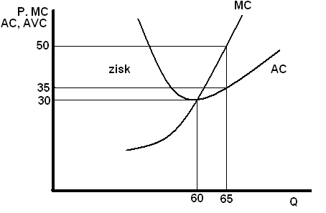

profit

1. In the figure below, mark the size of the total profit (or loss) of a perfectly competitive company which maximizes profit – is it a profit or loss?

